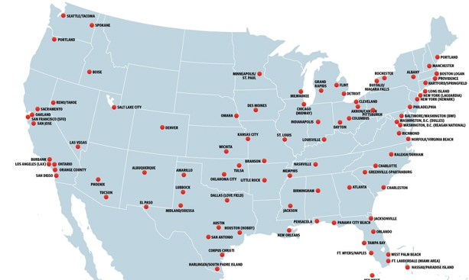

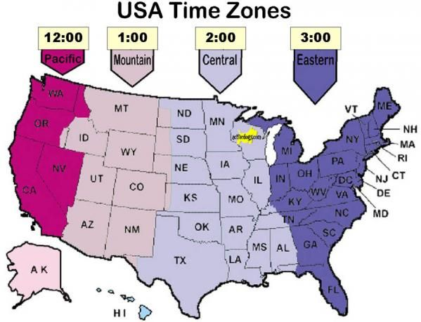

Sunday | Monday | Tuesday | Wednesday | Thursday | Friday | Saturday
 |  |  |  |  | February 23  SW Flight  CLE to Vegas  11:40am- | Feb 24
Feb 25 | Feb 26 | Feb 27 | Feb 28 | March 1 | March 2 | March 3
March 4 | March 5

Places we are going:

Camp Park Army Base (staying with Aunt Joanie) Dublin CA
Downtown Pleasanton CA

Winchester Mansion

Uncle Cory’s Coast Guard Base
USS Hornet (Aircraft Carrier)

Tour of all downtown San Fran
California Academy of Science
Golden Gate Bridge
Palace of Fine Arts
??**Exploratorium**??

Alcatraz
Fisherman’s Wharf
Aquarium of the Bay
Wax Museum (Madame Tussauds)
Ripley’s Believe it Or Not
Eating at Aliota’s Restaurant

Go Car Tour of China Town
The Presidio (old military base)
Walt Disney Museum

Muir Woods

?? Monterey Bay??

